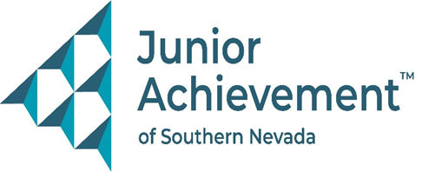
June 5, 2025
FOR IMMEDIATE RELEASE:

Junior Achievement of Southern Nevada Welcomes Shawn Danoski from DC Building Group to Board of Directors

LAS VEGAS – Junior Achievement of Southern Nevada announces the appointment of Shawn Danoski, founder and CEO of DC Building Group, to its Board of Directors. Danoski brings more than two decades of construction leadership, strategic planning, and community engagement to the nonprofit organization that empowers young people to own their economic success through programs in financial literacy, work readiness, and entrepreneurship. The addition of Danoski to the board underscores JA’s dedication to strong community partnerships and experienced leadership.

A Las Vegas native and longtime advocate for youth development and education, Danoski has led DC Building Group since its founding in 2001. Under his leadership, the company has earned a reputation for delivering high-quality commercial construction projects and cultivating strong client relationships throughout Southern Nevada.
Danoski’s extensive board service includes current positions with the Nevada Contractors Association, NAIOP, and the Clark County Building Enterprise Fund Advisory Committee (BEFAC). Past board service includes the Nevada State Contractors Board Commission Construction Education, City of Las Vegas Board of Appeals, UNLV College of Engineering Board, NAIOP president, and Nevada Childhood Cancer Foundation, among others.
“Shawn has already made a lasting impact on Junior Achievement,” said Michelle Jackson, president and CEO of Junior Achievement of Southern Nevada. “His company played a key role in the completion of our beautiful, new JA Inspiration Center, reducing costs significantly while delivering an incredible space that will help us teach thousands of local students about the ‘business of life’. We’re honored to have his leadership and vision on our board.”
Danoski holds a Bachelor of Science in Construction Management from the University of Nevada, Las Vegas. He and his wife, Amber, have been married for 25 years and are active supporters of numerous community charities. Their shared commitment to giving back continues to inspire others across the region.

About Junior Achievement of Southern Nevada
Founded locally in 1996, Junior Achievement of Southern Nevada, Inc. is dedicated to providing financial education to K-12 students and young adults with a curriculum including wants vs. needs, budget management to economic principals, workforce skills, credit and entrepreneurship. The completion of the new 40,000-square-foot Junior Achievement of Southern Nevada Inspiration Center will allow the nonprofit organization to impact more than 60,000 local youth. It is now the permanent site for capstone programs, Betty’s JA BizTown and JA Finance Park. Junior Achievement of Southern Nevada’s financial literacy mission is accomplished with the support of 285 businesses and 6,800 business role models, who help youth learn about the “business of life,” by helping bridge the gap between what youth learn in school and the real world. For more information visit https://jasnv.org/ and follow on Instagram and Facebook.

# # #

MEDIA CONTACT:
Nancy Katz, Purdue Marion & Associates, 702-349-0063 or nancy@purduemarion.com

